March 27, 2023 – Java Project – Thea Gregory 5291240

Today and this weekend I worked on the following:

* Completed edit/delete restaurant
* Made the MVC for Create and Edit Menu
* Began Delete Menu
* Created menu, manager, restauranteur tables in mysql DB and set up foreign keys

My progress was a bit slower than I’d hoped, but I still made good speed and am confident that I will finish on time. I am very happy with how well my queries are turning out and how effective they are at handing the amount of connecting data this application needs to work with. I did, however, have a few issues. I spend a good amount of time learning about JTables. I wanted to set it up so when I clicked on the JTable selection that it would populate the fields without needing to click a button. It took some time, but I figured out how to do it and as a result my program is much cleaner looking and feels more user-friendly and intuitive. I did have an embarrassing hour-long bug that was the result of a misplaced bracket, but I managed it figure it out on my own and move on.

Screenshots:

Create Menu View:

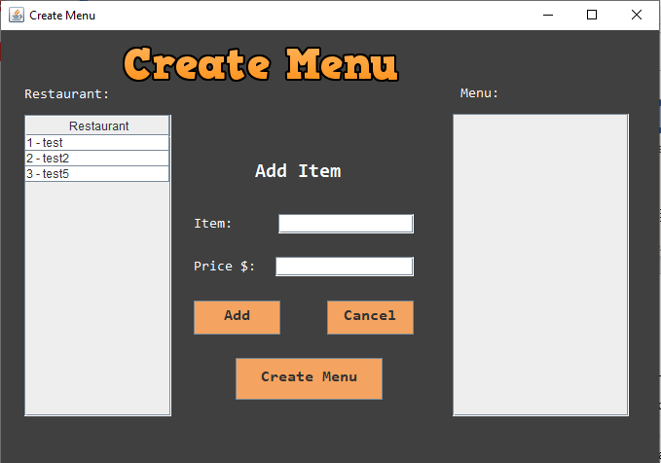

Edit Menu View with selections deployed (note that only restaurants with menus will appear):

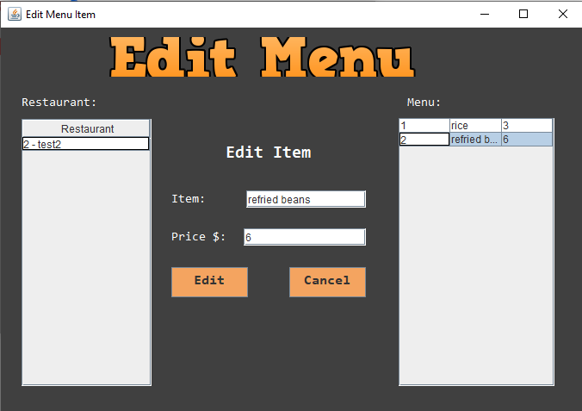

Code to display the restaurant’s menu in the right screen:

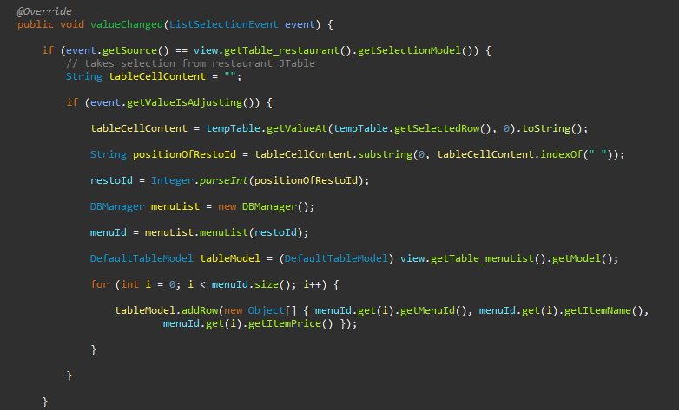

The code to apply the edits to the menu in the db:

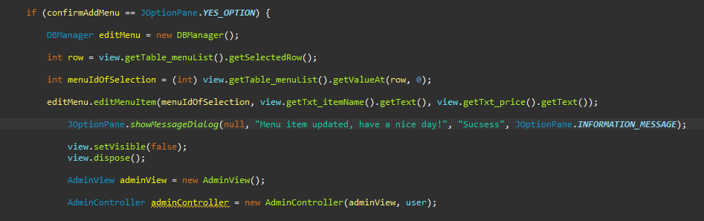

MenuItem class:

